**AIR TRAFFIC CONTROL (EASY)**

**Task:**

After years of being an IT student, Kory decided that this job wasn't for him and he was destined to be something greater. He wanted to be like Frank Abagnale Jr, a infamous felon who gained notoriety in the late 1970s by claiming a diverse range of workplace frauds which you can see in the book and movie "Catch me if you can".

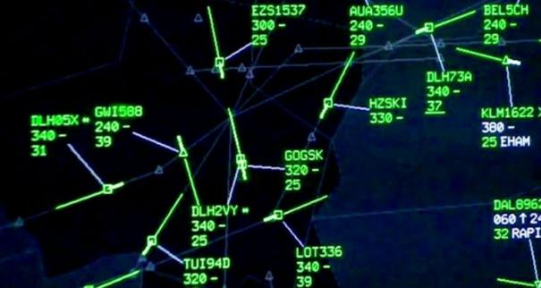As an air traffic controller, Kory's job is to ensure the safe and efficient flow of air traffic within a designated airspace and around airports. His primary responsibility is to prevent collisions between aircraft and provide safe and orderly movement of flights, both in the air and on the ground. Lucky for him, he got the job with no problem thanks to his skillfull talking and charismatic. Unlucky for the people who's on the planes that day because Kory definitely doesn't know how to do his job properly. As his partner in crime, you need to help him find whether or not two airplane will crash.

**Input:**

The first line of input contains C:/Users/Kory/AppData/Local/Temp/wps.ESmGknwps C:/Users/Kory/AppData/Local/Temp/wps.HkyuDvwps. Each of the C:/Users/Kory/AppData/Local/Temp/wps.bwYKoXwpsremaining lines describe two line segments with six integers C:/Users/Kory/AppData/Local/Temp/wps.yrmTaawps. The first line segment goes through C:/Users/Kory/AppData/Local/Temp/wps.tkYlNhwpsand C:/Users/Kory/AppData/Local/Temp/wps.BTIzbuwps, the second line segment goes through C:/Users/Kory/AppData/Local/Temp/wps.ywSZZtwpsand C:/Users/Kory/AppData/Local/Temp/wps.hiZvVewps.

**Output:**

For each test, print "YES" if the line segments intersect and "NO" otherwise.

**Sample**

|  |  |
| --- | --- |
| Input | Output |
| 5  1 1 5 3 1 2 4 3  1 1 5 3 1 1 4 3  1 1 5 3 2 3 4 1  1 1 5 3 2 4 4 1  1 1 5 3 3 2 7 4 | NO  YES  YES  YES  YES |